# Imdat telefaks no:

## Ben Ben Ben

## duyamyorum konuamyorum sakatm

## 

*Faksı kim gönderiyor ?*

### Isim:________________________________ Kendi faks numaranz:____________________

*Yardim nereye gelsin?*

### Cadde:_______________________________ Ev no:_______________ Kat:_______________

### ehir________________________________________________________________________

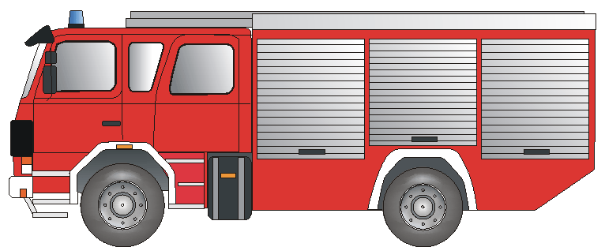Kimden yardim istiyorsunuz?  ***Ne oldu?***

________________________________________________________________________________________________________________________________________________________________________________________________________________________

**Itfaiye** Yangn Acil durum Trafik kazas

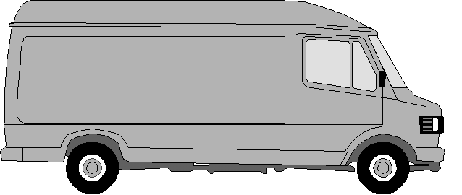

### **Can kurtaran** Acil doktor Yaralanma Hastalk

### 

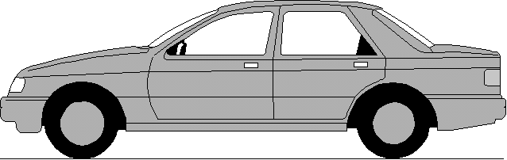

# **POLIZEI**

**Polis** Hrszlk Baskn Kavga

#### *çok teşekkür ederim ! Imza:________________________*

**Lütfen geri fakslayın! Lütfen geri fakslayın! Lütfen geri fakslayın! Lütfen geri fakslayın!**

##### Imdat telefaksιnιz bize ulastι Ve yardιm ________________________________________________

***size gelmek üzere yola çιkmιş bulunuyor.*** Yetlinin Imzas:_____________________________

Ein Service der BD Frankfurt am Main und des Deutschen Schwerhörigenbund e. V. – Referat „Barrierefreies Planen und Bauen“/2011